Develop vector auto regression model for multivariate time series data forecasting
EX:No.10
DATE:19/04/25

AIM:
Write a program to Develop vector auto regression model for multivariate time series data forecasting

ALGORITHM:
Step 1: Install required libraries (if not already installed).
Step 2: Import necessary libraries (pandas, numpy, matplotlib).
Step 3: Load air pollution data, parse dates, and set 'date' as the index.
Step 4: Remove duplicate timestamps and fill missing values.
Step 5: Select the 'pollution_today' column.
Step 6: Remove outliers using the IQR method.
Step 7: Ensure daily data frequency.
Step 8: Resample to weekly average (optional, not used in the plot).
Step 9: Create a figure and plot daily pollution levels as a line graph.
Step 10: Set labels, title, and legend for the plot.
Step 11: Show the plot.

CODE:

import pandas as pd
import numpy as np
import matplotlib.pyplot as plt
from statsmodels.tsa.api import VAR
from statsmodels.tsa.stattools import adfuller
# 1. Load the dataset
file_path = r"C:\Users\HARISH\Desktop\notes\time series and analysis pratical\ex 6\accident_time_series_1000_rows.csv"
df = pd.read_csv(file_path)

df['Date'] = pd.to_datetime(df['Date'])
df.set_index('Date', inplace=True)

# 2. Select relevant columns
data = df[['Total Accidents', 'Fatal Accidents', 'Injuries']]

# 3. Check stationarity function
def check_stationarity(series):
result = adfuller(series)
return result[1] < 0.05 # Stationary if p-value < 0.05

# 4. Difference if needed
diff_data = data.copy()
for col in diff_data.columns:
if not check_stationarity(diff_data[col]):
print(f"{col} is not stationary. Differencing applied.")
diff_data = diff_data.diff().dropna()

# 5. Fit the VAR model
model = VAR(diff_data)
lag_order = model.select_order(maxlags=15).aic
print(f"Selected Lag Order (AIC): {lag_order}")
var_model = model.fit(lag_order)
print(var_model.summary())

# 6. Forecast
forecast_steps = 10
forecast = var_model.forecast(diff_data.values[-lag_order:], steps=forecast_steps)
forecast_df = pd.DataFrame(forecast, columns=data.columns)

# 7. Inverse transform to original scale
last_known = data.iloc[-1]
forecast_cumsum = forecast_df.cumsum()
forecast_final = forecast_cumsum + last_known.values
forecast_final = pd.DataFrame(forecast_final, columns=data.columns)

# 8. Create future date index for plotting
forecast_index = pd.date_range(start=data.index[-1] + pd.Timedelta(days=1), periods=forecast_steps)
forecast_final.index = forecast_index
# 9. Plot actual vs forecast
plt.figure(figsize=(14, 7))
for col in data.columns:
plt.plot(data.index, data[col], label=f'Actual {col}')
plt.plot(forecast_final.index, forecast_final[col], linestyle='--', label=f'Forecast {col}')
plt.title("VAR Model Forecast - Multivariate Time Series")
plt.xlabel("Date")
plt.ylabel("Values")
plt.legend()
plt.grid(True)
plt.tight_layout()
plt.show()

OUTPUT:

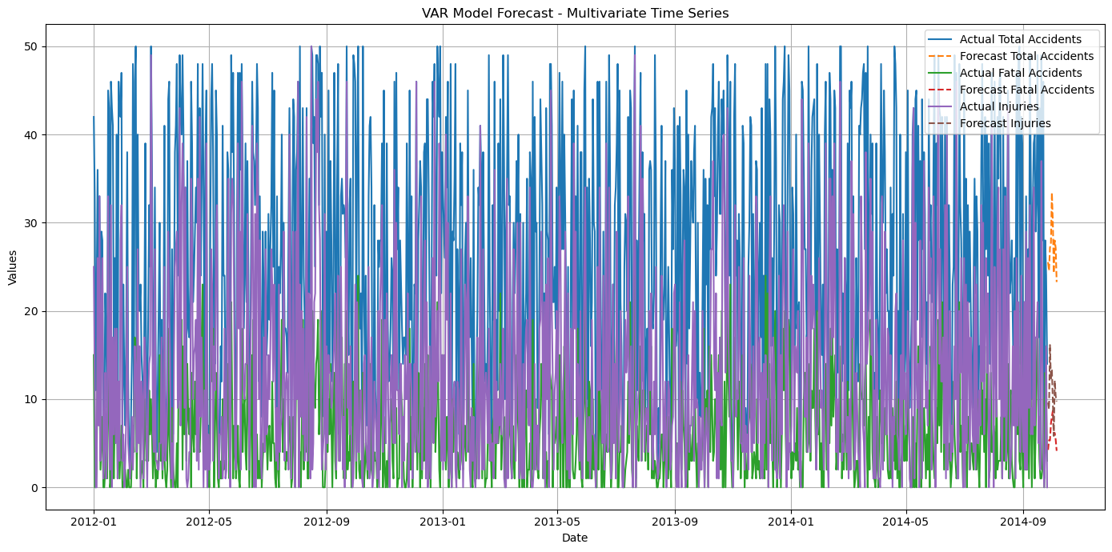

RESULT:
Thus, the program using the time series data implementation has been done successfully.

